# Softuniada 2019

## Plants

An interesting conflict between two species is taking place on the newly renovated Gaf Inatiev Boulevard (*any similarities to real places and events are purely coincidental*… *honest!*). What makes it even more interesting is the two species are… plants! Exciting, right? Well, one of them is actually a fungus, so not really a plant, but the other one is a tree, so – close enough.

The battle is happening on the new grates around the trees on the boulevard – around each tree there are channels for its roots to grow. Each tree’s grate has between 1 and 359 channels, starting from the tree and going outwards in a radial pattern. The lengths of all the channels are the same (i.e. if you have e.g. 359 channels with a length of 5cm, this essentially creates a circle with a radius of 5cm).

The tree’s **roots** start growing **from the center** of the grate **towards the outside**, but a species of **fungus** has started growing on the **outside**, **towards the** **center**. The tree and the fungus are **incompatible** – the roots of the tree can’t grow over the fungus, and the fungus cannot grow over the tree. They can reach each other, but **not overlap**.

The **tree** grows only during the **day**, the **fungus** grows only during the **night**. During a single **day**, the tree can only **grow along a single channel**. The fungus can also grow only along a **single channel during the night** (it does not have to be in the same channel in which the tree grew during the day). Both the fungus and the tree grow by integer increments.

Both the tree and the fungus **must grow during each day/night**, and they can only grow in **parts** of the channels which are **not occupied**. If the tree **can’t grow** during the day, it **dies**. If the fungus **can’t grow** during the night, it **dies**. Hence the conflict – the **first one that fails to grow** (due to all the space in the channels being occupied) **dies**. *This grate ain’t big enough for both of ‘em, wild-west style*.

The tree and the fungus have evolved to **compete optimally** in this conflict. Each of them will always **grow optimally**, **if possible**. This means that they will choose such a length of **growth along a single channel**, that their “opponent” is **either prevented from growing**, or forced into a **position where there is no possible optimal move** (i.e. a position that eventually will lead to them not being able to grow, if the current player continues to grow optimally).

You are examining a specific grate during the beginning of **the day**. You see the **number** of channels, the **length** of each tree **root** **along each channel**, the **length** of the **fungus** **along** **each channel**, and the **radius** of the channels (i.e. the radius of the grate).

Your task is to write a program which, given the above information, determines what the optimal growth for the tree is during this day. The answer should contain the **number of a channel**, **as ordered in the input**, **starting from** 0, and the **length** of the growth. If there are **multiple** optimal options for the growth, choose the one in the channel with the **lowest number**.

If there is **no optimal growth**, the program should **indicate that** (see the output description below).

### Input

The first line of the standard input will contain the integer number N – the number of channels.

Each of the next N lines will contain two integer numbers, separated by a single space – the **length of the root** and the **length of the fungus** in that channel (starting from channel 0 and ending in channel N-1).

The last line of the standard input will contain the integer number R – the radius of the grate, i.e. the length of each channel.

### Output

The output should consist of a single line on the standard output.

If there is a optimal growth option, the output should be in the format:  
grow I by L   
where I is the number of the channel (as ordered in the input) and L is the length of the growth. If there are multiple options, print the one with the lowest channel number**.** For example, if the optimal growth options are channel 3 by a length of 5 and channel 1 by a length of 7, the output should be "grow 1 by 7".

If there is no optimal growth option, print three dashes:  
---

### Illustration

Here is a situation with a grate, which has only 2 channels, with a radius of 7 (the grate channels are divided into sections to illustrate their length of 7, the brown sections are tree roots, the green sections are fungus):

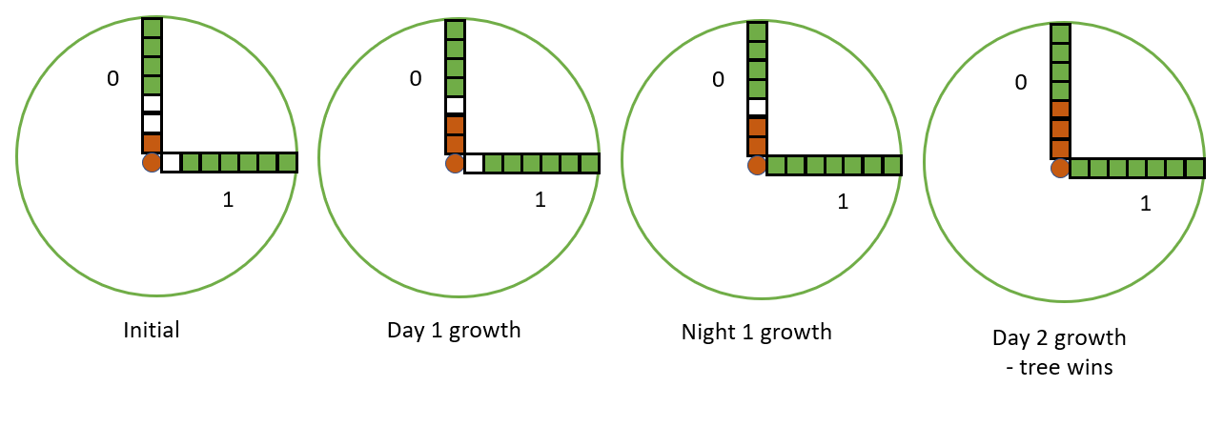

In the initial state, channel 0 has a root with a length of 1 and a fungus length of 4. Channel 1 has a root length of 0 and a fungus length of 6. Since this is the beginning of the day, the tree will grow. The optimal growth for day 1 is in channel 0 by 1. That way the fungus is forced to grow by 1 either in channel 0 or channel 1 during night 1 (note that this is a bad position). Wherever the fungus grows during night 1, it will fill up the channel leaving only 1 channel free – the tree grows in that in day 2, so during night 2 the fungus can’t grow and will die.

### Restrictions

0 < N < 360

0 < R < 1001

No root or fungus length inside a channel will be longer than R.

There is **no limit to the length** the tree/fungus can grow during a day/night, but they may only grow inside a **single channel** per day/night.

Each root is a single segment and each fungus growth inside a channel is a single segment – *you can’t “skip over” the sections in the illustration above*.

N and R will be integers.

### Examples

|  |  |  |
| --- | --- | --- |
| **Input** | **Output** | **Explanation** |
| 2  1 4  0 6  7 | grow 0 by 1 | See the illustration |
| 3  5 1  0 7  2 3  10 | grow 1 by 2 | The tree grows in channel 1, by a length of 2. This is the only optimal growth in this situation, and it leaves the fungus in a situation where regardless of its growth, the tree can force it into a similar situation until the last growth remains for the tree |
| 5  1 1  0 2  2 0  0 2  2 0  4 | grow 0 by 2 | There are multiple optimal growths for the tree here, but we pick the one with the lowest channel number – 0 |
| 4  0 2  2 0  0 2  2 0  4 | --- | The tree can’t survive if the fungus grows optimally. There is an even number of equally empty channels. If the tree grows fully into a channel, the fungus will grow fully in another and due to the even number of repetitions will be the last to grow. If the tree grows by 1 in any channel, the fungus will grow by 1 in any other channel and the tree will be placed in effectively the same position. |